Q1. Explain Array in java programming?

Ans:

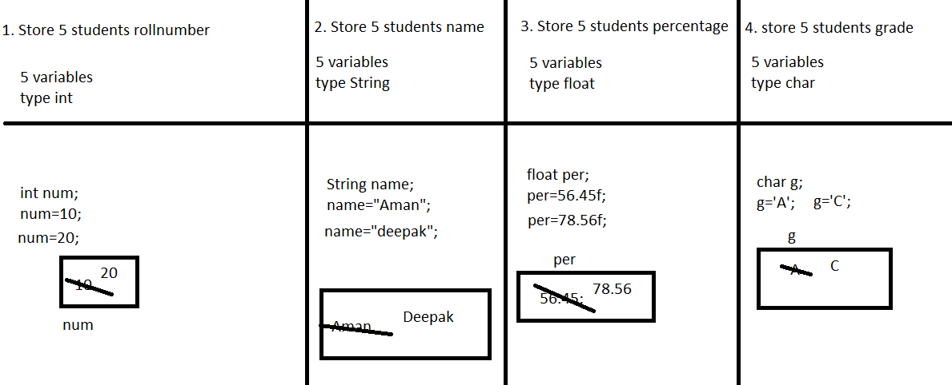

If we want to store multiple values under single variable name then we should go for Array

* Arrays are collection of same types of data
* In case of Array memory allocation is continuous
* Values stored in array are known as Elements
* Elements of the array accessed by index
* Java Does not support negative index
* In java index always starts with 0.
* In java array are dynamic
* We allocate memory dynamically using new keyword
* We can accesses array elements randomly and sequentially

1. **Declaration of the Array**

**Syntax:**

Datatype arrayName[]=new Datatype[size];

Size must not be Negative,float,double,String

Examples:

int nums[]=new int[5];//valid

int x[5];//invallid

int x[];

x=new int[5];

float per[]=new float[5];

String names[]=new String[5];

char g[]=new char[5];

1. **Initialization of the Array: Assign some vales to the array**

**Syntax:**

**Type1:**

**Example:**

int nums[]=new int[5];

Initialization

Syntax:

ArrayName[INDEX]=value;

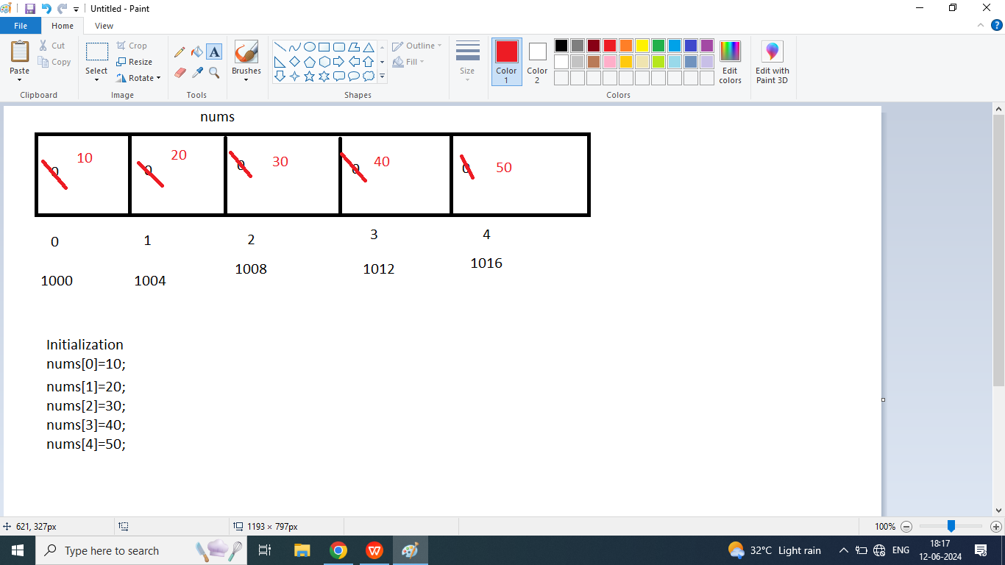

1. **Print elements of the Array**

System.out.println(arrayName[index]);

